ORGANIC CHEMISTRY - - Revision Problems

Alkanes

1. Name the following alkanes:
a) C₃H₈ b) CH₃ - CH₂ - CH₂ - CH₂ - CH₂ - CH₂ - CH₂ - CH₂ - CH₂ - CH₃

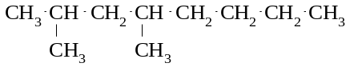
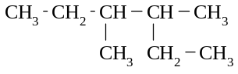
c) d)

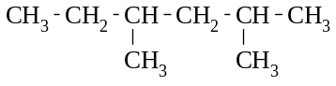
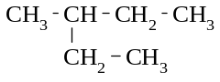
e) f)

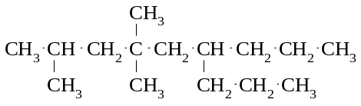
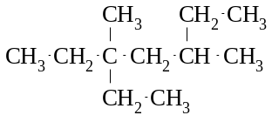

g) h)

i) (CH₃)₂CHCH₂CH(CH₃)₂ j) CH₃C(CH₃)₂CH(CH₂CH₃)CH₂CH₃

2. Give the structural formulae of the following
a) hexane b) 3-methylpentane c) 4-ethyl-2-methylheptane d) 2,4-dimethyl-4-propyloctane e) methylpropane f) ethylpentane

3. Which of the following substances make up a group of structural isomers?

A CH₃ CH₂ CH₂ CH₂ CH₂ CH₃ B CH₃ CH₂ CH₂ CH₂ CH₃
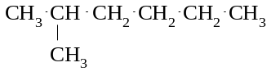
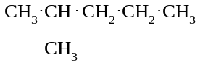
C D

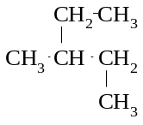
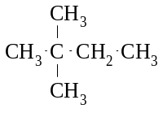

E F

4. Give the structural formulae and names of five structural isomers with the molecular formula of C₈H₁₈.

5. Write balanced equations for the following reactions.
a) 1 mole of bromine is reacted with 1 mole of methane in the presence of UV light.
b) 1 mole of fluorine is shaken with 1 mole of propane in the presence of sunlight.
c) 1 mole of chlorine is mixed with 1 mole of pentane and the mixture is placed in a dark cupboard.
d) Methane is shaken with an excess of iodine, in the presence of UV light.
e) Chlorine gas (in excess) is mixed with butane and the mixture is exposed to UV light for several hours.
f) Bromine and ethane are mixed in a 1:1 mole ratio. The mixture is then exposed to UV light for several hours.
g) Decane is burnt in air.

6. Give the structural formula of an example of each of the following:
a) an aliphatic hydrocarbon b) a straight chain alkane
c) a branched chain hydrocarbon d) an alicyclic alkane

7. Name the following compounds:
a) | 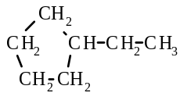 | b) | 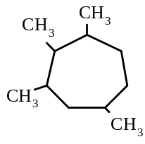
c)  CH₃  CH₃  CH₂ CH₂ CH₃  CH₂ CH₃ | 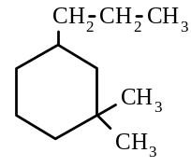 | d)

8. Give the structural formulae of the following:
a) methylcyclohexane b) 3-ethyl-1,1-dimethylcyclopentane

Alkenes
9. Draw electron dot diagrams of the following: a) ethane b) propene

10. Name the following substances:
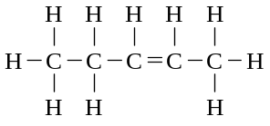
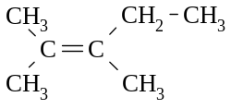
a) b)

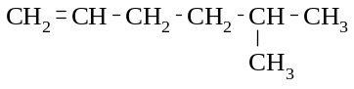
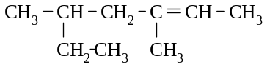
c) d)

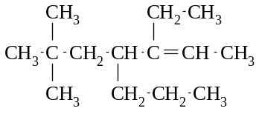
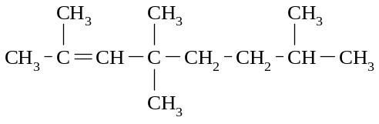

e) f)

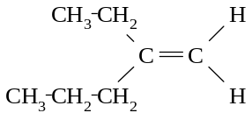
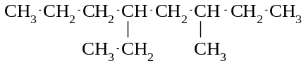

g) h)

11. Draw the structural formulae of the following:
a) 2,3-dimethylnon-4-ene b) methylpropene c) 3-ethyl-2,4-dimethylpent-2-ene

12. There are many structural isomers with the molecular formula of C₆H₁₂
a) Give the structural formulae and names of three isomers (of C₆H₁₂) which are alkenes.
b) Give the structural formulae and names of two isomers (of C₆H₁₂) which are cycloalkanes.

13. Give the structural formulae and names of the geometrical isomers of
a) 1,2-dichloroethene b) 1-chloro-2-fluoroethene c) but-2-ene
d) 1-bromopropene e) pent-2-ene

14. Which of the following substances exhibit geometrical isomerism?
a) propane b) propene c) 1,2-difluoroethene d) 1,2-dichloroethane e) 1,1-dichloroethene f) 1-chloro-2-bromoethene
g) 1,1-dibromo-2,2-difluroethene h) methylpropene i) 2-bromobut-2-ene j) 2-methylbut-2-ene k) 1,2-dibromo-1,2-dichloroethene l) hex-3-ene

15. Write equations for the following reactions. Show the formulae of the organic compounds as structural formulae.
a) Ethene is reacted with chlorine, in the absence of UV light
b) Propene is mixed with chlorine and allowed to react for a very short time.
c) But-1-ene is mixed with hydrogen in the presence of a catalyst.
d) A mixture of ethene and bromine (in excess) are allowed to react in the presence of UV light for several hours.
e) Ethane is mixed with an excess of fluorine and the mixture is exposed to ultraviolet light for several hours.
f) Iodine and pent-2-ene are mixed in a 1:1 mole ratio and allowed to react.
g) 2-methylbut-2-ene is reacted with fluorine in the absence of UV light.
h) Hex-1-ene is burnt in air.

16. Give the names of the following compounds:
a) | 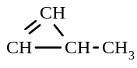 | b) | 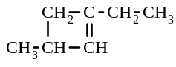
c) | 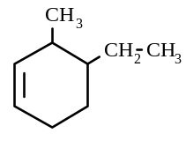 | d) | 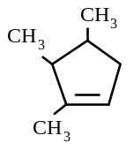

17. Draw the structural formulae of the following compounds:
a) 3-methylcyclohexene b) 1,2,3-trimethylcyclopentene
c) 1-ethyl-3-propylcycloheptane d) 4,4-dimethylcyclopentene

Alkynes
18. Give the names of the following:
a) H - C ≡ C - CH₃ b) CH₃ - CH₂ - C ≡ C - CH₃
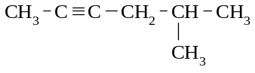
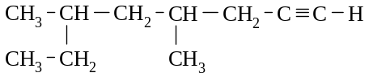
c) d)

19. Give the structural formulae of the following compounds:
a) dec-3-yne b) 4-ethyl-4,5-dimethylhex-2-yne

20. There are many structural isomers with the molecular formula of C₅H₈
a) Give the structural formulae and names of three isomers (of C₅H₈) which are alkynes.
b) Give the structural formulae and names of two isomers (of C₅H₈) which are cycloalkenes.
c) Give the structural formulae of two isomers (of C₅H₈) which are dienes (i.e. contain two double bonds).
21. Identify by name and structural formula each of the following:
a) an alkyne other than but-1-yne which has only four carbon atoms.
b) an alkane other than butane which has only four carbon atoms.
c) an unsaturated aliphatic hydrocarbon with a formula of C₆H₁₂.
d) a saturated hydrocarbon with a formula of C₄H₈.
e) an alicyclic hydrocarbon with a formula of C₄H₆

22. Write equations for the following reactions. Give structural formulae for the organic compounds. Identify each
reaction as an addition reaction or a substitution reaction.
a) 1 mole of ethyne is reacted with 1 mole of bromine.
b) 1 mole of propyne is reacted with 2 mole of chlorine.
c) but-1-yne is reacted with an excess of fluorine in the absence of UV light.
d) propyne is added to an excess of bromine and the mixture is allowed to react for several hours in the presence
of UV light.
e) the hydrogenation (reaction with hydrogen) of methylbutyne.
f) the reaction of 1 mole of ethane with 1 mole of chlorine in the presence of UV light
g) the reaction of ethene with bromine in the absence of UV light.
h) the preparation of chloromethane (CH₃Cl)
i) the preparation of 1,2-difluoropropane
j) the preparation of 2,3-dichlorobut-2-ene
k) the combustion of oct-1-yne

23. Draw four structural isomers of aromatic compounds with the formula C₉H₁₂. Name these isomers.

Halogen substituted alkanes
24. Name the following compounds:
a) CH₃ - CH₂ - CH₂ - CH₂ - CH₂ - F b) CH₂ = CH - CH₂ - CH₂ - Br

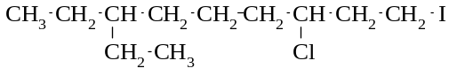
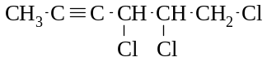
c) d)

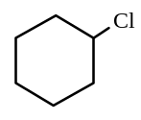
Br
Br
Br
Br

e) f)

25. Draw the structural formulae of the following compounds:
a) 1,2-dibromobutane b) 3-chloro-2-methylpent-1-ene
c) trans-2,3-difluorobut-2-ene d) cis-1,2-dichloropropene

26. Give the structural formulae and names of three structural isomers of the formula C₄H₇Cl . Include in your answer an aliphatic compound and an alicyclic compound.

27. Give the structural formulae and names of the geometrical isomers of
a) C₂H₂Br₂ b) C₄H₈

28. Give the structural formulae and names of the structural isomers of the formula C₂H₂Br₂.

Alcohols

29. Give the names of the following compounds:
a) CH₃ - CH₂ - CH₂ - CH₂ - CH₂ - CH₂ OH b) HO - CH₂ - CH₂ - CH₂ - CH₂ - OH

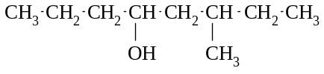
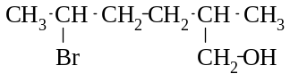
c) d)

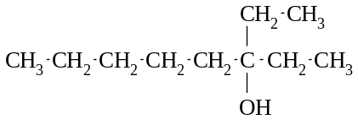
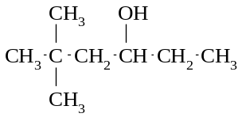

e) f)

30. Identify each of the alcohols in question 29. as a “primary”, “secondary” or “tertiary” alcohol.

31. Give the structural formulae of the following compounds:
a) pentan-2-ol b) trimethylbutan-2-ol c) 2-methylcyclohexanol d) 2,2-dichlorohexane-1,7-diol e) sodium methoxide f) butan-2-oxide ion

32. Methanol is very soluble in water because hydrogen bonds can form between the water molecules and the methanol molecules. Draw a diagram, using structural formulae, which shows how methanol molecules can hydrogen bond to water molecules.

33. Ethanol is a liquid at room temperature whereas ethane is a gas. Explain this observation.

34. Write equations, using structural formulae, for the following reactions:
a) sodium is added to water
b) sodium is added to ethanol
c) sodium is added to propan-2-ol

35. Give the structural formulae and names of a primary alcohol, a secondary alcohol and a tertiary alcohol with the
following formulae:
a) C₄H₁₀O b) C₆H₁₄O

Amines
36. Name the following compounds:
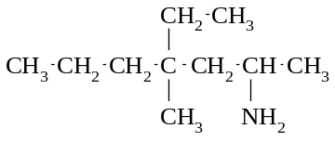
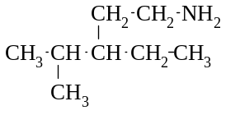
a) b)

37. Give the structural formulae of the following substances:
a) 2,4,4-trimethylhexan-2-amine b) 3-amino-2-methylbutan-1-ol

38. Give an equation, using structural formulae, for the reaction between propan-2-amine and hydrochloric acid.

39. Identify and name the functional groups in the following compounds:
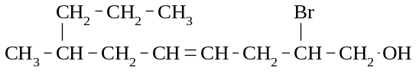
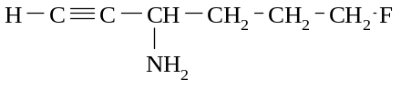
a) b)

TEE Questions

40. Which one of the following is a secondary alcohol?
A | 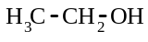 | B | 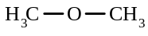 | C | 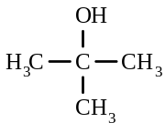
D | 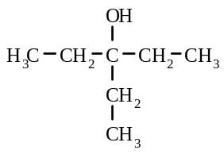 | E | 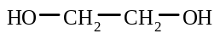

41. When an organic compound was treated with chlorine in the presence of ultraviolet light, a major reaction product was chlorocyclohexane. Which one of the following was the original organic compound?

A benzene B cyclohexane C cyclohexene

Cl
Cl
OH
D cyclohexanol E 1,1-dichlorocyclohexane

42. How many compounds are possible with formula C₂F₄Cl₂?
A 1 B 2 C 3 D 4 E 6

43. Which one of the following is a trans isomer?
A | 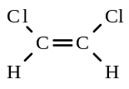 | B | 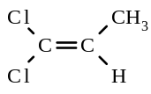 | C | 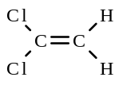
D | 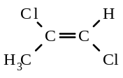 | E | 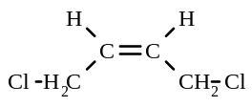

44. Draw structural formulae and give the names of all the isomers of molecular formula C₃H₅Cl.

45. An amine may be regarded as an alkyl-substituted ammonia. Butylamine (butan-1-amine, CH₃CH₂CH₂CH₂NH₂) is
a liquid with a low boiling point and a strong ammonia-like fishy smell.
a) When a sample of butylamine is shaken with excess 0.1 mol L⁻¹ hydrochloric acid the resulting solution has no
odour. What has happened to the butylamine molecules?
b) Why was the odour lost?
c) When a little 0.1 mol L⁻¹ sodium hydroxide is shaken with the resulting mixture the strong fishy stink returns.
Why is this?
d) Why was excess dilute hydrochloric acid needed to get rid of the odour, but only a little sodium hydroxide solution needed to bring it back?

46. A compound has the formula C₆H₁₂. Which one of the following could it be?
A A straight chain alkane B A branched chain alkane C An alkene with one double bond D An alkyne with one triple bond E An aromatic hydrocarbon

47. Write equations for any reactions that occur in the following procedures. In each case describe in full what you would observe, including any colours, odours, precipitates (give the colour), gases evolved (give the colour or describe as
colourless). If a reaction occurs but the change is not visible, you should state this.
a) Pent-1-ene is shaken with a little bromine water. b) A small piece of sodium is added to ethanol.
c) A piece of sodium metal is added to methanol

48. Identify by name or formula an example of each of the following.
a) A tertiary alcohol
b) A secondary alcohol with five carbon atoms
c) An alkane other than heptane whose molecule contains exactly seven carbon atoms.
d) A tertiary alcohol containing five carbon atoms.
e) A substance, other than water, which is a liquid at room temperature and pressure and which has hydrogen bonding between its molecules.

49. Briefly explain each of the following
Statement | Explanation
There are two isomers of 1,2-dichloroethene, but there is only one 1,2-dichloroethane
There are two isomers of 1,2-dichloroethene, but there is only one 1,1-dichloroethene

50. How many structural isomers are there of formula C₃H₆Cl₂?
A 1 B 2 C 3 D 4 E 5

51. Which of the following are tertiary alcohols?
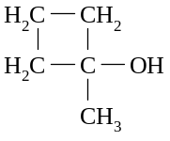
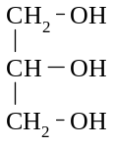
I II (CH₃)₃COH III CH₃CH₂CH₂OH IV

A I and II only B I, II and IV only C II and IV only
D II, III and IV only E All four alcohols

52. Write the systematic (IUPAC) name of each of the following:
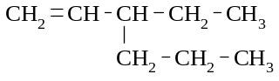
a) b)
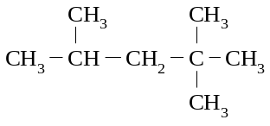

53. Give a chemical test which would distinguish between cyclohexane and cyclohexene. State the observations you would expect to make, and give the equation for any reaction.

54. Write structural formulae and systematic (IUPAC) names for all isomers of molecular formula C₂H₂Cl₂.

55. Draw the structures of the following species, representing all the valence shell electron pairs as either : or as -
a) trichloromethane (chloroform) b) chloroethane c) trans-1,2-dibromoethene

56. In which one of the following can geometric (cis/trans) isomerism occur?
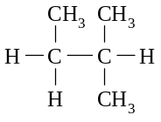
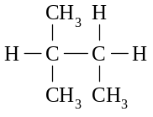
A B C (CH₃)₂C = CHCH₃

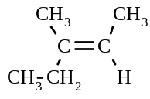
D CH₃CH₂CH=CHCH₃ E

57. Which of the following is a pair of isomers?
A and
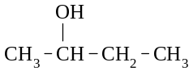
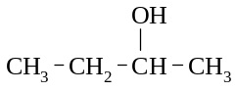

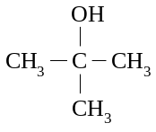

B and CH₃ - CH₂ - CH₂ - CH₂ - CH₂ - OH

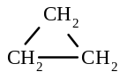

C CH₃ - CH₂ - CH₃ and

D CH₃ - CH₂ - OH and CH₃ - O- CH₃
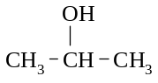
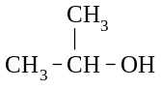
E and

58. Which of the compounds labelled P to S can have geometrical (cis/trans) isomers?
P Q R S
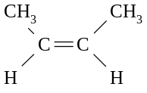
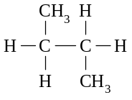
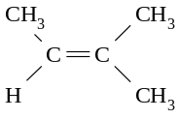
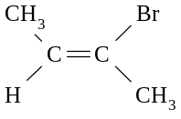

A P only B P and S only C P, Q, R and S
D P, Q and S only E P, R and S only

59. Which of the following formulae could represent a cycloalkane?
A C₂H₄ B C₅H₁₂ C C₄H₈ D C₃H₈ E C₄H₁₀

Miscellaneous multiple-choice questions

60. Which one of the following molecules can exhibit geometrical isomerism?
A C₂H₅ - CH = CH - CH₃ B CH₂ = CH - CH₂Br C CH₂Br - CH₂Br
D CH₃ - CH = C(CH₃)₂ E BrCH = CBr₂

61. Which one of the following compounds does NOT exhibit geometrical isomerism (i.e. form cis and trans isomers)?
A CH₃ CH₂ CH = CH CH₂ CH₃ B Br₂ C = CH Br
C CH₃ CH = CH Br D CH₃ CH = CH CH₂ CH₃

62. Which one of the following compounds has a dipole moment?
A CCl₄ B CH₃Br C CO₂ D CH₂ = CH₂ E BF₃

63 In which one of the following does geometrical isomerism exist?
A CH₂ = CH - CH₂Cl B (CH₃)₂C = CH - CH₃ C CH₃ - CH₂ - CH = CHCl D ClCH₂ - CH₂Cl E ClCH₂ - CH₂ - CH = CCl₂

64. Consider the following structures:

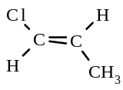  (1) | 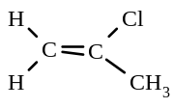  (2) | 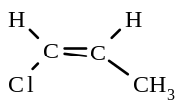  (3) | 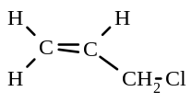  (4)

Which are isomers?
A (1) and (3) only B (1), (2) and (3) only C (2), (3) and (4) only D (1) and (2) only E (1), (2), (3) and (4)

65. Which of the following statements are true about the compound represented by the formula below?
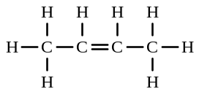
I it decolourises bromine water II it is soluble in water
III it undergoes addition reaction with hydrogen chloride IV its systematic name is trans but- 2-ene
A I only B I and III only C I, III and IV only
D I, II, III and IV E II and III only

66. An isomer of a given chemical compound is another compound which has
A the same molecular weight but a different chemical composition
B the same empirical formula but a different molecular formula
C the same molecular weight but is radioactive
D the same molecular formula but different molecular weight
E the same molecular formula but different properties

67. For the substances C(graphite), N₂, C₃H₈ and C₂H₅OH, which of the following correctly represents them in order of
increasing boiling point?
A N₂, C₃H₈, C₂H₅OH, C B N₂, C, C₃H₈, C₂H₅OH C N₂, C, C₂H₅OH, C₃H₈
D C, N₂, C₃H₈, C₂H₅OH E C₃H₈, N₂, C₂H₅OH, C

68. If an equal mass of each of the following is burned in excess oxygen which will give the greatest mass of CO₂?
A CH₄ B CH₃OH C C₂H₂ D CH₃CH₂OH E CH₃COOH

69. For which of the following compounds would you expect hydrogen bonding to play a significant role in determining the boiling point?
H₂O, C₂H₆, CH₃Br, C₂H₅OH, CH₃NH₂
A H₂O only B H₂O, CH₃Br and C₂H₅OH only
C H₂O and CH₃NH₂ only D H₂O, C₂H₅OH and CH₃NH₂ only
E all of them

70. Which one of the following best describes the molecular shape, polarity of bonds and molecular polarity in a CCl₄
molecule?
molecular shape polarity of bonds molecular polarity
A tetrahedral polar covalent non-polar
B square planar polar covalent non-polar
C tetrahedral ionic polar
D square planar ionic polar
E tetrahedral non-polar covalent non-polar

71. Which of the following equations represent an addition reaction?
I CH₃ - CH = CH₂ + Br₂ → CH₃ - CHBr - CH₂Br II CH₂ = CH₂ + H₂ → CH₃ - CH₃
III CH₃ - CH₃ + Br₂ → CH₃ - CH₂Br + HBr IV C₆H₆ + Br₂ → C₆H₅Br + HBr
A I and II only B III and IV only C I, II and IV only
D I only E IV only

72. Which one of the following compounds does not exhibit geometrical isomerism?
A CHCl = CHCl B CH₃CH = CHCH₃ C CH₃CH = CCl₂
D CH₃CH = CHCl E CH₃ClC = CClCH₃

73. Which one of the following molecules has a zero dipole moment?
A Cl₃C - CCl₃ B (CH₃)₃CH C CHCl₃
D HO - CH₂ - CH₂ - OH E NH₃

74. Which of the following are isomeric with pentane?
I | II | III | IV | V
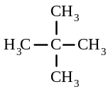 | 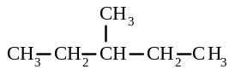 | 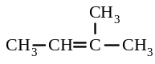 | 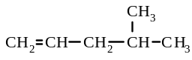 | 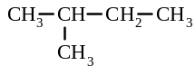
A I, II and V B I, III and V C I and V D II only E II and IV

75. Which of the following substances would you expect to have the highest boiling point?
A | 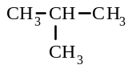 | B | 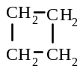 | C CH₃ - CH₂ - CH₂ - CH₃
D CH₃ - CH₂ - O - CH₂ - CH₃ E CH₃ - CH₂ - CH₂ - CH₂OH

76. Which of the following compounds is unsaturated?
A pentane B cis-but-2-ene C dichloromethane D ethanol E ethanamine

77. Which of the following formulae can represent two substances which are cis and trans geometric isomers?
A C₄H₁₀ B C₃H₆ C CH₂ClCH₂Cl D CHClCHCl E CH₂CCl₂

78. Which of the following molecules is planar?
A NH₃ B C₂H₄ C C₂H₆ D C₃H₆ E PCl₃
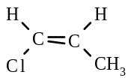
79. The structural formula for cis-1-chloropropene is

Which, if any, of the following is the correct structural formula for the trans isomer of this molecule?
A | 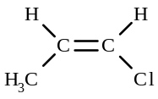 | B | 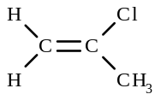 | C | 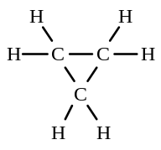
D | 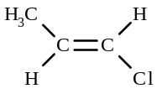 | E | None of the above is the trans isomer.

80. Which of the following statements best explain the stability of benzene?
A Cyclo hydrocarbons are more stable that linear hydrocarbons.
B The benzene ring structure contains three double bonds.
C Benzene is an unsaturated hydrocarbon.
D Six delocalised electrons are present in the ring structure of benzene.
E The benzene ring is planar.

81. In which of the following substances are the intermolecular forces the greatest?
A Ice B Solid hydrogen sulfide C Solid ammonia
D Solid ethanol E Solid methane

82. Which one of the following compounds readily undergoes addition reaction?
A ethyne B ethane C benzene D bromoethane E ethanol

83. Which of the following reactions are substitution reactions?
I CH₄ + Cl₂ → CH₃Cl + HCl II HC≡CH + HCl → CH₂=CHCl
III CH₂=CH₂ + Br₂ → CH₂Br-CH₂Br IV C₆H₆ + Br₂ → C₆H₅Br + HBr
A I and II B II and IV C II and III D I only E I and IV

84. Which of the following substances is a tertiary alcohol?
A CH₃CH₂CH₂OH B CH₂(OH)CH(OH)CH₂OH C CH₃CH₂CH(OH)CH₂CH₃ D CH₃CH(OH)CH₃ E CH₃C(CH₃)₂OH

Miscellaneous short-answer questions

85. Name the following compounds:
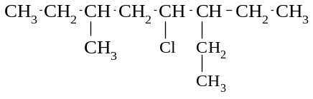
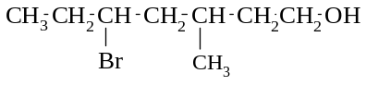
a) b)

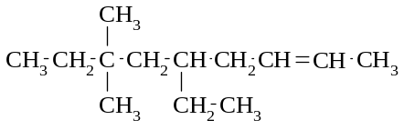
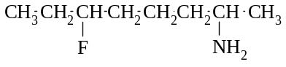
c) d)

e) f)
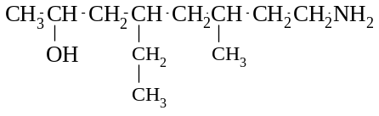
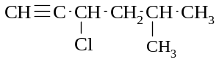

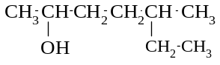
g) h) C₆H₅Cl

i) | 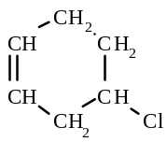 | j) | 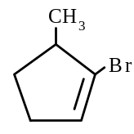 | k) | 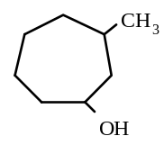

86. Give the structural formulae of the following
a) 2-chloropentan-1-amine b) 2,3-dimethylbut-2-ene c) 4-bromo-2-methylhexan-2-ol d) cyclohexanamine e) 3-methylcyclopentanol f) 3-ethyl-4-methylpent-1-yne
g) 1,2-dichlorobenzene h) methanol i) ethyne j) 1,1,2-trimethylheptan-1-amine

87. Give the structural formulae, and names of three structural isomers with the following molecular formulae:
a) C₅H₁₂ b) C₄H₈ c) C₅H₈ d) C₄H₉Cl e) C₄H₉OH

88. Give the structural formulae and names of three structural isomers of 1,1-dibromocyclopentane.

89 Sketch the structural formulae of the following:
a) trans-1,2-dibromoethene b) cis-1,2-dichloroethene c) cisbut-2-ene
d) trans-1-chlorobut-1-ene e) trans-1-chloroprop-1-ene f) cis-2-bromobut-2-ene

90. Write an equation for each of the following reactions:
a) methane is reacted with excess chlorine in the presence of U.V. light.
b) ethene is reacted with hydrogen gas, in the presence of a catalyst.
c) propene is reacted with hydrogen bromide gas.
d) butyne is burnt.
e) the combustion of ethanol
f) methanamine is reacted with hydrochloric acid
g) sodium is added to propanol
h) propan-1-amine is reacted with nitric acid
i) sodium is added to methanol

91. Name the following alcohols, and identify each as a primary, secondary or tertiary alcohol.
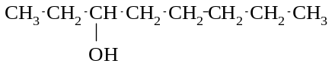
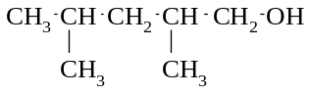
a) b)

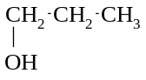
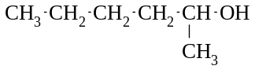
c) d)

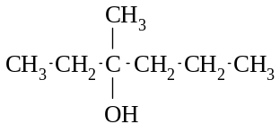
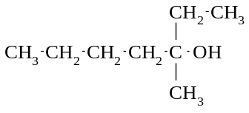

e) f)

92 The questions below refer to the following organic compound:

a) What is the correct IUPAC name for the compound?
b) Give the structural formula of the product formed when the compound reacts with chlorine, in the absence of
ultraviolet light.
c) Give the balanced equation for the complete combustion of the organic compound.
d) Give the structural formulae of a pair of cis-trans isomers that have the same molecular formula as the organic compound.

93. Draw the structural formula and name each of the following:
a) an alkyne containing three carbon atoms per molecule
b) a cyclic alkene containing six carbon atoms per molecule
c) an aromatic hydrocarbon containing seven carbon atoms per molecule
d) an amine containing seven hydrogen atoms per molecule

Answers:

1. a) propane b) decane c) 2,4-dimethyloctane
d) 3,4-dimethylhexane e) 2,4-dimethylhexane f) 3-methylpentane
g) 2,4,4-trimethyl-6-propylnonane h) 3-ethyl-3,5-dimethylheptane i) 2,4-dimethylpentane
j) 3-ethyl-2,2-dimethylpentane
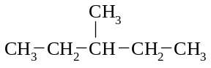

2. a) CH₃ - CH₂ - CH₂ - CH₂ - CH₂ - CH₃ b)

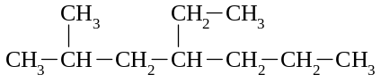
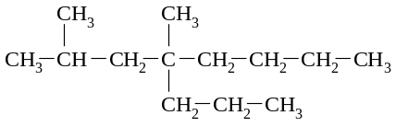

c) d)

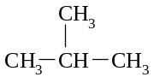
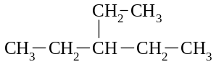

e) f)

3. A, D, E, F
4. CH₃ - CH₂ - CH₂ - CH₂ - CH₂ - CH₂ - CH₂ - CH₃ octane
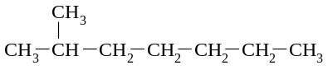
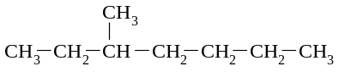

2-methylheptane 3-methylheptane
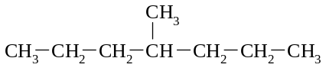
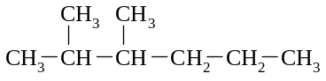

4-methylheptane 2,3-dimethyhexane
also
2,2-dimethylhexane, 2,4-dimethylhexane, 2,5-dimethylhexane, 3,3-dimethylhexane, 3,4-dimethylhexane,
2,2,3-trimethylpentane, 2,2,4-trimethylpentane, 2,3,3-trimethylpentane, 2,3,4-trimethylpentane,
3-ethyl-2-methylpentane, 3-ethyl-3-methylpentane, tetramethylbutane
5. a) CH₄ + Br₂ → CH₃Br + HBr
b) CH₃ - CH₂ - CH₃ + F₂ → CH₃ - CH₂ - CH₂F + HF
c) no reaction
d) CH₄ + 4 I₂ → CI₄ + 4HI
e) CH₃ - CH₂ - CH₂ - CH₃ + 10 Cl₂ → CCl₃ - CCl₂ - CCl₂ - CCl₃ + 10 HCl
f) CH₃ - CH₃ + Br₂ → CH₃ - CH₂Br + HBr
g) 2 C₁₀H₂₂ + 31 O₂ → 20 CO₂ + 22 H₂O
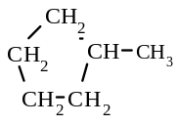
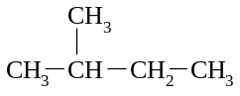

6. a) CH₃ - CH₃ b) CH₃ - CH₂ - CH₂ - CH₃ c) d)

7. a) ethylcyclopentane b) 1,2,3,5-tetramethylcycloheptane
c) 1,1-dimethyl-3-propylcyclohexane d) 5-ethyl-1,2-dimethyl-3-propylcyclooctane
8 | a) | 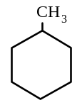 | b) | 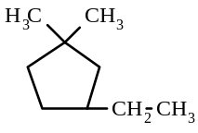

9. a) b)
H
H
H
H
H
H
C
C
H
C
C
C
H
H
H
H
H

10. a) pent-2-ene b) 3-methylpent-2-ene c) 5-methylhex-1-ene
d) 3,5-dimethylhept-2-ene e) 2,4,4,7-tetramethyloct-2-ene
f) 3-ethyl-6,6-dimethyl-4-propylhept-2-ene g) 2-ethylpent-1-ene h) 5-ethyl-3-methyloctane
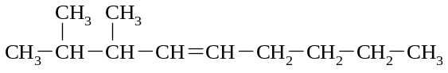
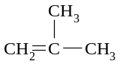
11. a) b)

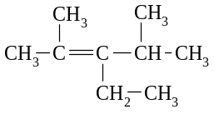

c)

12. a) CH₂ = CH - CH₂ - CH₂ - CH₂ - CH₃ hex-1-ene CH₃ - CH = CH - CH₂ - CH₂ - CH₃ hex-2-ene
CH₃ - CH₂ - CH = CH - CH₂ - CH₃ hex-3-ene etc
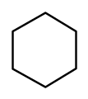
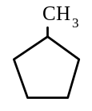
b) cyclohexane methylcyclopentane etc

13 | a) | cis-1,2-dichloroethene |  | trans-1,2-dichloroethene | 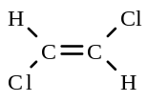
 | b) | cis-1-chloro-2-fluoroethene | 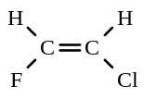 | trans-1-chloro-2-fluoroethene | 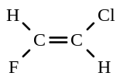
 | c) | cis-but-2-ene | 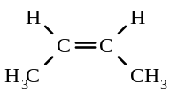 | trans-but-2-ene | 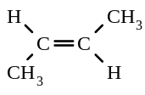
 | d) | cis-1-bromopropene | 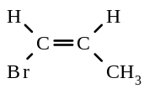 | trans-1-bromopropene | 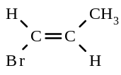
 | e) | cis-pent-2-ene | 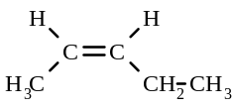 | trans-pent-2-ene | 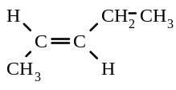

14. c) 1,2-difluoroethene f) 1-chloro-2-bromoethene i) 2-bromobut-2-ene
k) 1,2-dibromo-1,2-dichloroethene l) hex-3-ene
15. a) CH₂ = CH₂ + Cl₂ → CH₂Cl - CH₂Cl
b) CH₂ = CH - CH₃ + Cl₂ → CH₂Cl - CHCl - CH₃
c) CH₂ = CH - CH₂ - CH₃ + H₂ → CH₃ - CH₂ - CH₂ - CH₃
d) CH₂ = CH₂ + 5 Br₂ → CBr₃ - CBr₃ + 4HBr
e) CH₃ - CH₃ + 6 F₂ → CF₃ - CF₃ + 6HF
f) CH₃ - CH = CH - CH₂ - CH₃ + I₂ → CH₃ - CHI - CHI - CH₂ - CH₃
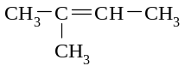
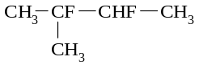
g) + F₂ →

h) C₆H₁₂ + 9 O₂ → 6CO₂ + 6H₂O

16. a) 3-methylcyclopropene b) 1-ethyl-3-methylcyclobutene
c) 4-ethyl-3-methylcyclohexene d) 2,3,4-trimethylcyclopentene

17 | a) | 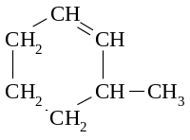 | b) | 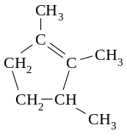
c) d)
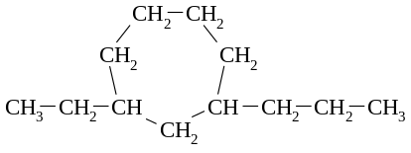 | 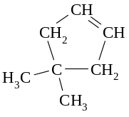

18. a) propyne b) pent-2-yne c) 5-methylhex-2-yne d) 4-6-dimethyloct-1-yne
19 | a) |  | b) | 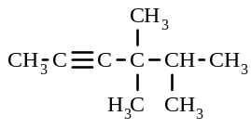

20. a) CH ≡ C - CH₂ - CH₂ - CH₃ pent-1-yne CH₃ - C ≡ C - CH₂ - CH₃ pent-2-yne
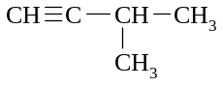
3-methylbut-1-yne etc

b)
cyclopentene | 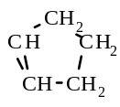 | 1-methylcyclobutene | 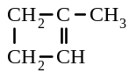

c) CH₂ = CH - CH = CH - CH₃ CH₂ = CH - CH₂ - CH = CH₂ etc

21. a) but-2-yne CH₃ - C ≡ C - CH₃
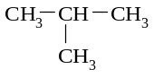
b) methylpropane or cyclobutane or methylcyclopropane

c) hex-1-ene, hex-2-ene, hex-3-ene, 2-methylpent-1-ene etc
d) cyclobutane or methylcyclopropane
e) cyclobutene or methylcyclopropene

22. a) CH ≡ CH + Br₂ → CHBr = CHBr addition reaction
b) CH ≡ C - CH₃ + 2Cl₂ → CHCl₂ - CCl₂ - CH₃ addition reactions
c) CH ≡ C - CH₂ - CH₃ + 2F₂ → CHF₂ - CF₂ - CH₂ - CH₃ addition reaction
d) CH ≡ C - CH₃ + 6 Br₂ → CBr₃ - CBr₂ - CBr₃ + 4HBr addition & substitution
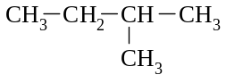
e) + 2 H₂ → addition

f) CH₃ - CH₃ + Cl₂ → CH₂Cl - CH₃ + HCl substitution
g) CH₂ = CH₂ + Br₂ → CH₂Br - CH₂Br addition
h) CH₄ + Cl₂ → CH₃Cl + HCl (in presence of UV light) substitution
22. i) CH₂ = CH - CH₃ + F₂ → CH₂F - CHF - CH₃ addition
j) CH₃ - C ≡ C - CH₃ + Cl₂ → CH₃ - CCl = CCl - CH₃ addition
k) 2C₈H₁₄ + 23 O₂ → 16 CO₂ + 14H₂O

23. 1,2,3-trimethylbenzene 1-ethyl-2-methylbenzene propylbenzene etc
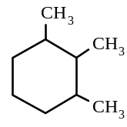 | 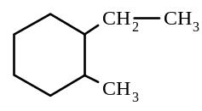 | 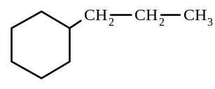

24. a) 1-fluoropentane b) 4-bromobut-1-ene c) 7-ethyl-3-chloro-1-iodononane
d) 4,5,6-trichlorohex-2-yne e) 1,2,3,4-tetrabromocyclohexane f) chlorobenzene

25 | a) | BrCH₂ - CHBr - CH₂ - CH₃ | b) | 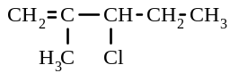
 | c) | 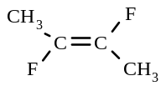 | d) | 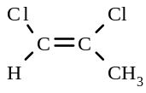

26. CH₂ = CH - CH₂ - CH₂Cl 4-chlorobut-1-ene CH₃ - CH = CH - CH₂Cl 4-chlorobut-2-ene etc
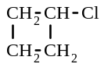 | chlorocyclobutane etc

27 | a) | cis-1,2-dibromoethene | 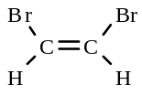 | trans-1,2-dibromoethene | 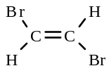
 | b) | cis-but-2-ene | 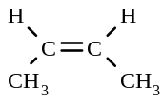 | trans-but-2-ene | 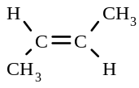

28. CHBr = CHBr 1,2-bibromoethene CBr₂ = CH₂ 1,1-dibromoethene
29. a) hexan-1-ol b) butane-1,4-diol c) 6-methyloctan-4-ol
d) 5-bromo-2-methylhexan-1-ol e) 5,5-dimethylhexan-3-ol f) 3-ethyloctan-3-ol
30. a) primary alcohol b) primary alcohol c) secondary alcohol
d) primary alcohol e) secondary alcohol f) tertiary alcohol
31 | a) | 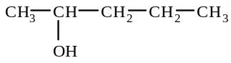 | b) | 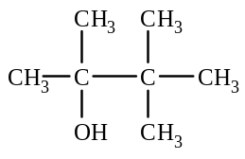
 | c) | 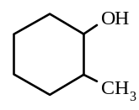 | d) | 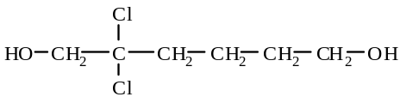
 | e) | CH₃O⁻ Na⁺ | f) | 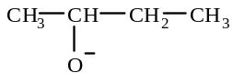
32.
hydrogen bond
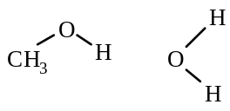
33. The bonds between ethanol molecules are hydrogen bonds, but between ethane molecules there are only dispersion forces. Hydrogen bonds are stronger than dispersion forces, for molecules of similar size. Thus, ethanol is a liquid
which has stronger bonds between molecules compared to the forces between molecules in a gas.
34. a) 2Na + 2H₂O → 2Na⁺ + 2 OH⁻ + H₂
b) 2Na + 2CH₃ - CH₂ OH → 2Na⁺ + 2 CH₃ - CH₂O⁻ + H₂
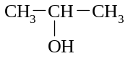
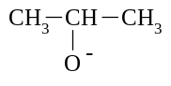
c) 2Na + 2 → 2Na⁺ + 2 + H₂

35. a) butan-1-ol (primary) butan-2-ol (secondary) methylpropan-2-ol (tertiary)
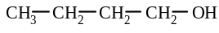 | 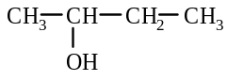 | 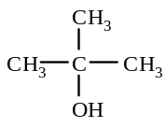

b) hexan-1-ol (primary) hexan-2-ol (secondary) 2-methylpentan-2-ol (tertiary)
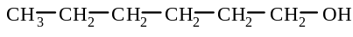 | 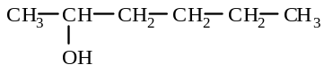 | 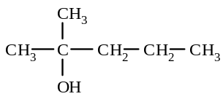

36. a) 4-ethyl-4-methylheptan-2-amine b) 3-ethyl-4-methylpentan-1-amine

37 | a) | 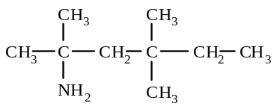 | b) | 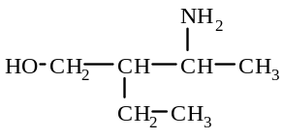
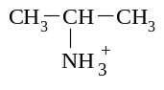
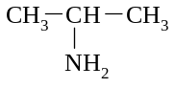
38. + H⁺ →

bromo
39. a)
alcohol
alkene

alkyne
fluoro
b)
amine

40. C 41. B 42. B 43. D
44.
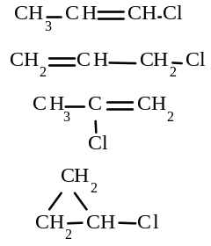
1-chloropropene (cis- and trans- isomers)

3-chloropropene

2-chloropropene

chlorocyclopropane
45. a) The butylamine molecules accept hydrogen ions from the hydrochloric acid, to form an ionic compound
CH₃CH₂CH₂CH₂NH₂ + H⁺ → CH₃CH₂CH₂CH₂NH₃⁺
b) Ionic compound are not very volatile, and so rarely have a smell. But butylamine is volatile (because low boiling
point indicates weak forces between butylamine molecules)
c) When NaOH is added, the ‘amine ion’ reacts with hydroxide ions to form butylamine again:
CH₃CH₂CH₂CH₂NH₃⁺ + OH⁻ → CH₃CH₂CH₂CH₂NH₂ + H₂O
d) Only a few molecules of butylamine are required to produce enough smell to be detected. So, a large amount of HCl was required to react with nearly all the amine molecule to get rid of the stink. However, only a small
amount of NaOH was required to reform a few molecules of the amine to cause th smell again.
46. C
47. a) CH₃ CH₂ CH₂ CH = CH₂ + Br₂ → CH₃ CH₂ CH₂ CHBr - CH₂Br
Orange colour of bromine layer becomes colourless.
b) 2CH₃CH₂OH + 2Na → 2CH₃CH₂O⁻Na⁺ + H₂
Grey solid disappears and colourless gas evolved
c) 2CH₃OH + 2Na → 2CH₃ O⁻Na⁺ + H₂
Grey solid disappears and colourless gas evolved
48. a) 2-methylpropan-2-ol b) pentan-2-ol c) 2-methylhexane
d) 2-methylbutan-2-ol e) methanol, ethanol
49.
Statement | Explanation
There are two isomers of 1,2-dichloroethene, but there is only one 1,2-dichloroethane | The two isomers of 1,2-dichloroethene are the cis and trans isomers that form because the double bonded carbons cannot rotate around the double bond. However, with 1,2-dichloroethane, the carbons are bonded with a single bond and so rotation can occur around this bond and so geometrical isomers do not form.
There are two isomers of 1,2-dichloroethene, but there is only one 1,1-dichloroethene | The two isomers of 1,2-dichloroethene are the cis and trans isomers that form because on each double bonded carbon there are two different groups of atoms. But with 1,1-dichloroethene, on each carbon there are two identical atoms. When this occurs, geometrical isomers do not exist, and so there is only one isomer of 1,1-dichloroethene.

50. D
51. A
52. a) 2,2,4-trimethylpentane b) 3-ethylhex-1-ene
53. Test - add an aqueous solution of bromine to each, and shake
Observation - with cyclohexene - the orange colour will disappear, but with cyclohexane -the orange colour will
remain
Equation C₆H₈ + Br₂ → C₆H₈Br₂
54. 1,1-dichloroethene cis-1,2-dichloroethene trans-1,2-dichloroethene
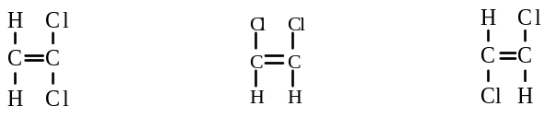
Cl
Cl
Cl
C
H
Cl
C
C
H
H
H
H
H
Br
Br
C
C
H
H
55. a) b) c)

56. D 57. D 58. B 59. C
60. A 61 B 62 B 63 C 64 E
65 B 66 E 67 A 68 C 69 D
70 A 71 A 72 C 73 A 74 C
75 E 76 B 77 D 78 B 79 D
80 D 81 A 82 A 83 E 84 E
85. a) 4-chloro-3-ethyl-6-methyloctane b) 5-bromo-3-methylheptan-1-ol
c) 5-ethyl-7,7-dimethylnon-2-ene d) 6-fluorooctan-2-amine
e) 8-amino-4-ethyl-6-methyloctan-2-ol f) 3-chloro-5-methylhex-1-yne
g) 5-methylheptan-2-ol h) chlorobenzene
i) 4-chlorocyclohexene j) 2-bromo-3-methylcyclopentene
k) 3-methylcycloheptanol
86.
a) | 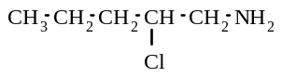 | b) | 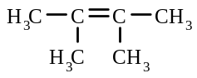 | c) | 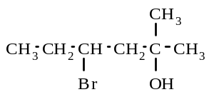
d) | 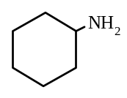 | e) | 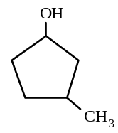 | f) | 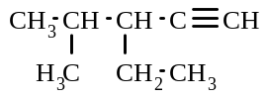
g) | 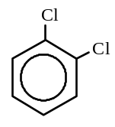 | h) | CH₃OH | i) | CH ≡ CH
j) | 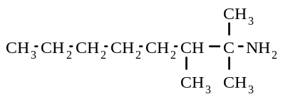
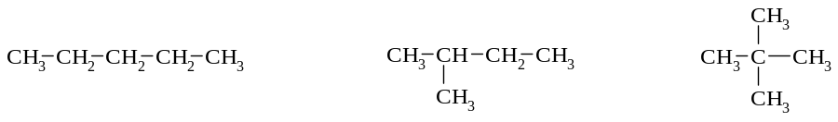

87. a)

pentane methylbutane dimethylpropane

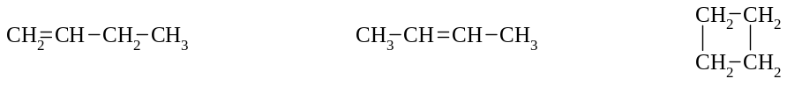
b)

but-1-ene but-2-ene cyclobutane
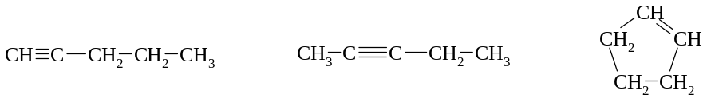
c)

pent-1-yne pent-2-yne cyclopentene
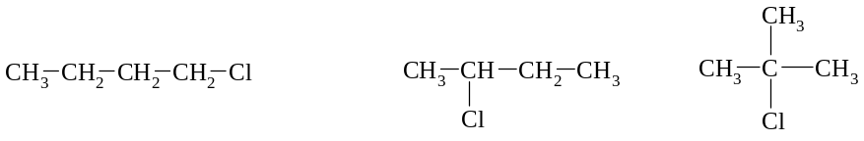

d)

1-chlorobutane 2-chlorobutane 2-chloromethylpropane

87. e)
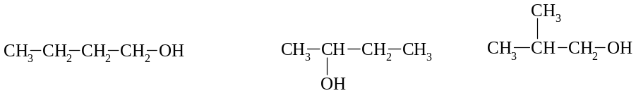

butan-1-ol butan-2-ol methylpropan-1-ol

88. 1,1-dibromocyclopentane has an empirical formula of C₅H₈Br₂, so, we are looking for isomers of C₅H₈Br₂.
There are many isomers, three typical ones are:
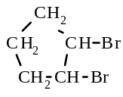 | 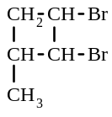 | 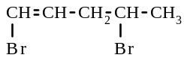
1,2-dibromocyclopentane 1,2-dibromo-3-methylcyclobutane 1,4-dibromopent-1-ene

89 | a) |  | b) | 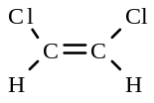 | c)
 | d) | 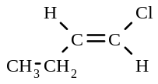 | e) | 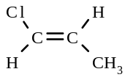 | f) | 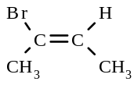

90. a) CH₄ + 4Cl₂ → CCl₄ + 4HCl
b) CH₂ = CH₂ + H₂ → CH₃ - CH₃
c) CH₃ CH = CH₂ + HBr → CH₃ CH₂ CH₂ Br or CH₃ CH(Br) CH₃
d) 2C₄H₆ + 11 O₂ → 8CO₂ + 6H₂O
e) CH₃ CH₂OH + 3 O₂ → 2CO₂ + 3H₂O
f) CH₃ NH₂ + H⁺ + Cl⁻ → CH₃ NH₃⁺ + Cl⁻
g) 2 CH₃ CH₂ CH₂OH + 2Na → 2 CH₃ CH₂ CH₂O⁻ + 2Na⁺ + H₂
h) CH₃ CH₂ CH₂ NH₂ + H⁺ → CH₃ CH₂ CH₂ NH₃⁺
i) 2CH₃OH + 2Na → 2CH₃O⁻ + H₂ + 2Na⁺

91. a) octan-3-ol secondary alcohol b) 2,4-dimethylpentan-1-ol primary alcohol
c) propan-1-ol primary alcohol d) hexan-2-ol secondary alcohol
e) 3-methylhexan-3-ol tertiary alcohol f) 3-methylheptan-3-ol tertiary alcohol
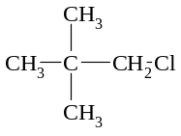
92. a) methylpropene b)

c) C₄H₈ + 6 O₂ → 4CO₂ + 4H₂O
d)
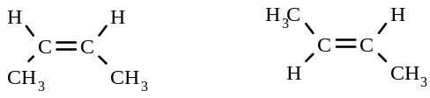

93. | a) | propyne | b) | 4-methylcyclopentene
 |  | 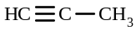 |  | 